I used the following scenario to measure performance and profile the application:

* User logs in
* Opens a post
* Writes a comment
* Deletes the comment
* Logs out

In the Jmeter program I set number of threads to 100 and ran the test. Here's the final graph:

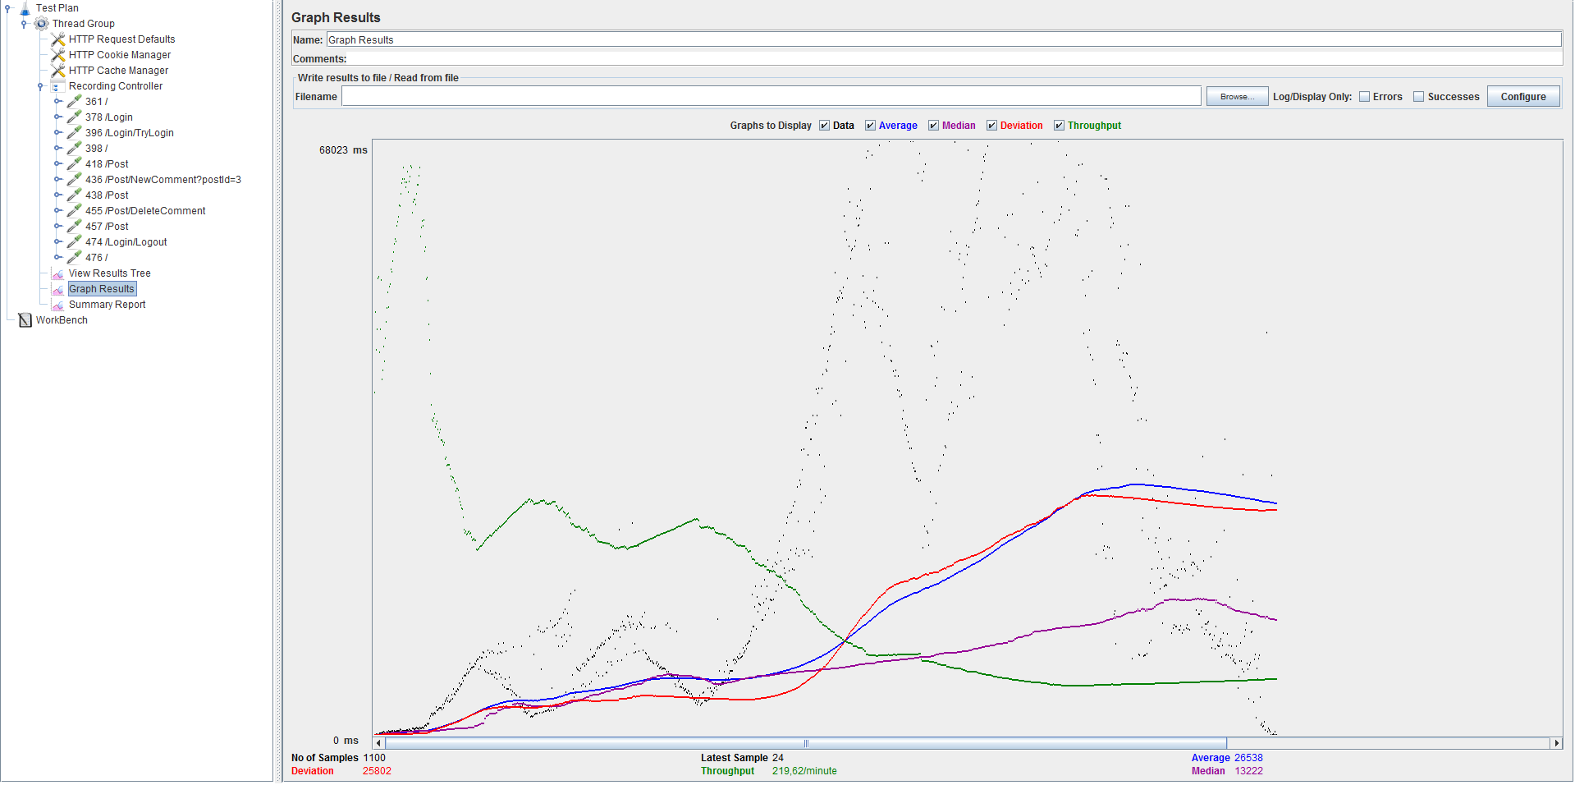

Throughput is about 220 requests/minute.

In them meantime I profiled the application with Visual Studio. Here's a screenshot of the results:

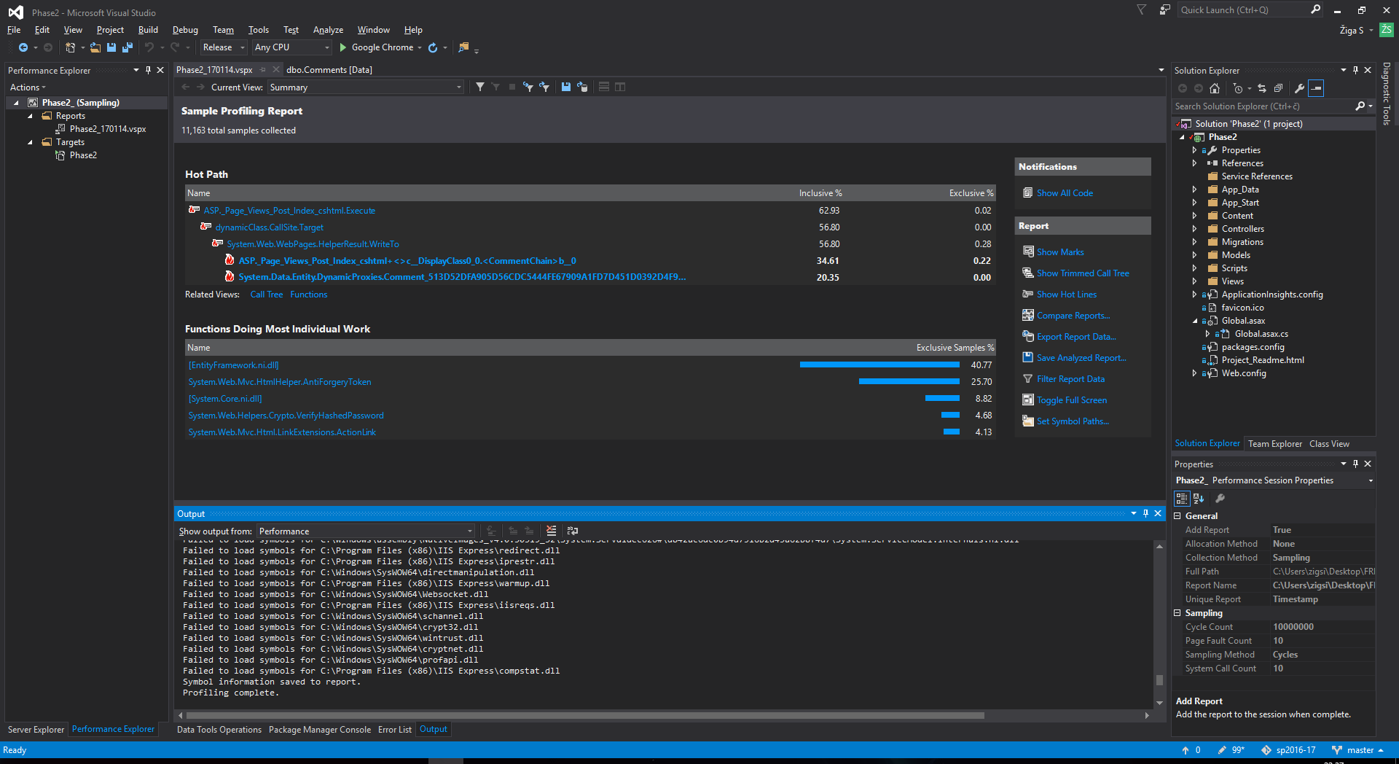

We can see that the most work was done by the EntityFramework (database). During each step it has to show all comments in the post, while adding and modifying new and existing comments in the comment table. Because of ACID, that was the expected bottleneck.

Right after EntityFramework is CSRF token validation, which seems reasonable as 3 out of 5 actions include CSRF validation.

The website was running on i7 6700K 4.0GHz, 16GB RAM, SSD drive.